**The Cupid Training Environment**

**Tutorial**

This tutorial will take you through the process of installing the Cupid Plugin for the Eclipse Integrated Development Environment (IDE) and using some of its basic functionality. Cupidis a training environment for graduate students and early career geoscience modelers who have some basic programming experience, but are new to the geoscience model development process. Cupid simplifies the process of configuring a computational environment capable of compiling and executing high-performance geoscience models such as NASA’s ModelE and models using advanced coupling infrastructure software such as the Earth System Modeling Framework (ESMF).

IDEs package a lot of development tools into a single application to help manage and simplify the software development workflow. Although IDEs aim to increase developer productivity, they can still introduce a steep learning curve for new geoscience modelers. Some challenges with using IDEs include:

* Understanding the basic steps involved in moving from source code to a running model
* Making sense of the many development tools and features available in the IDE
* Setting up a high-performance computational environment capable of configuring, compiling and executing model code
* Configuring the IDE to connect to remote computational environments

Using Cupid, you will be able to select a training scenario and, within a few minutes, configure, compile, execute, and view the output of both skeleton models and realistic models.

More information about Cupid can be found at: <https://earthsystemcog.org/projects/cupid/>

**Install Eclipse and the Cupid Plugin**

1. **Download and install Eclipse for Parallel Application Developers, version 4.3.1 SR1 (Kepler).**

The main download page is: <http://www.eclipse.org/downloads/>.

There is a list of available Eclipse packages. Be sure to choose “Eclipse for Parallel Application Developers” as it will come pre-bundled with the necessary plugins for working with remote systems.

1. **Unpack the downloaded file into a local directory and run Eclipse by double clicking on the Eclipse executable.**

The first time you start Eclipse, you will be prompted to select a location for your workspace. Choose an empty folder.

1. **Install the Cupid Plugin from the Cupid Update Site.**
   1. Click Help🡪Install New Software

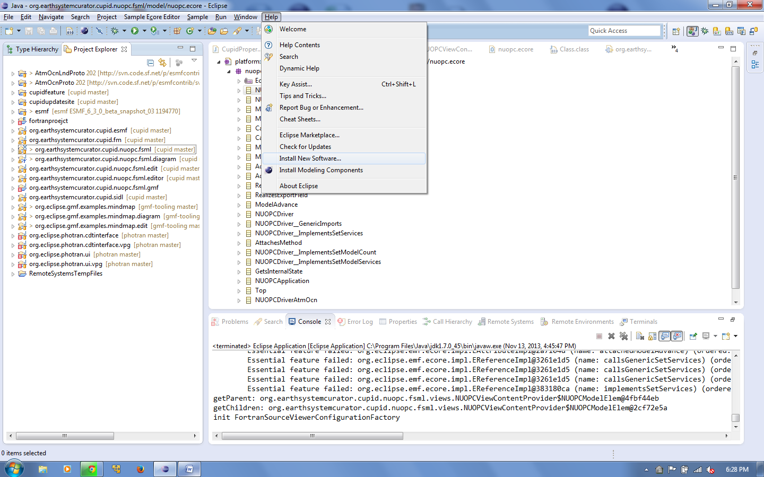

* 1. Put the Cupid Update Site URL into “Work with...” You will be prompted to give the update site a name of your choosing.

The URL is: **http://www.cc.gatech.edu/~rocky/cupid/**

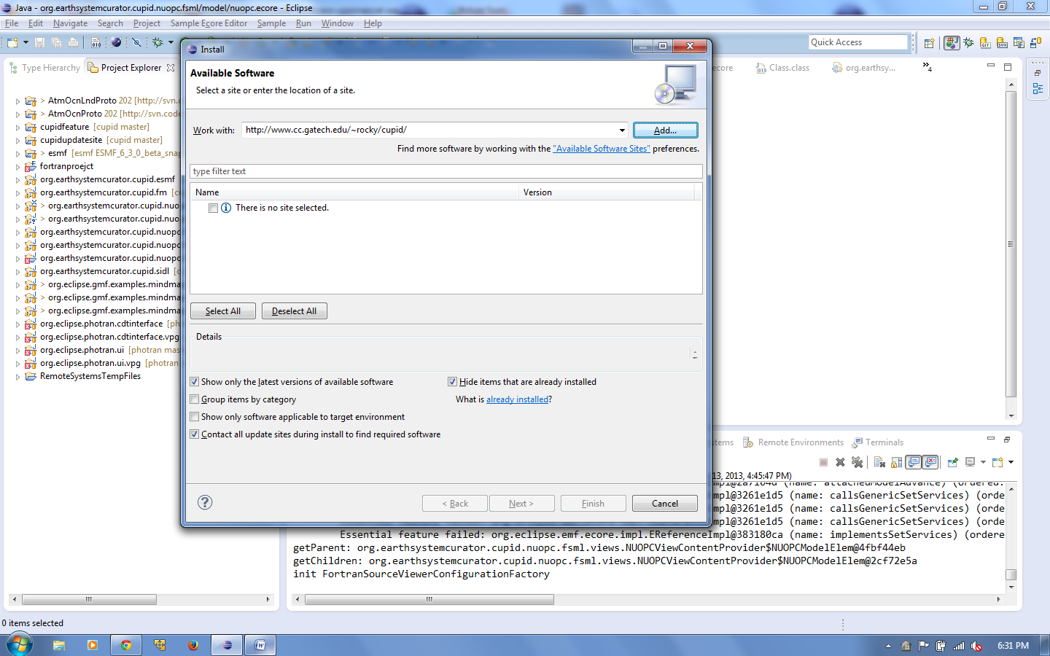

* 1. Uncheck the “Group items by category” option.

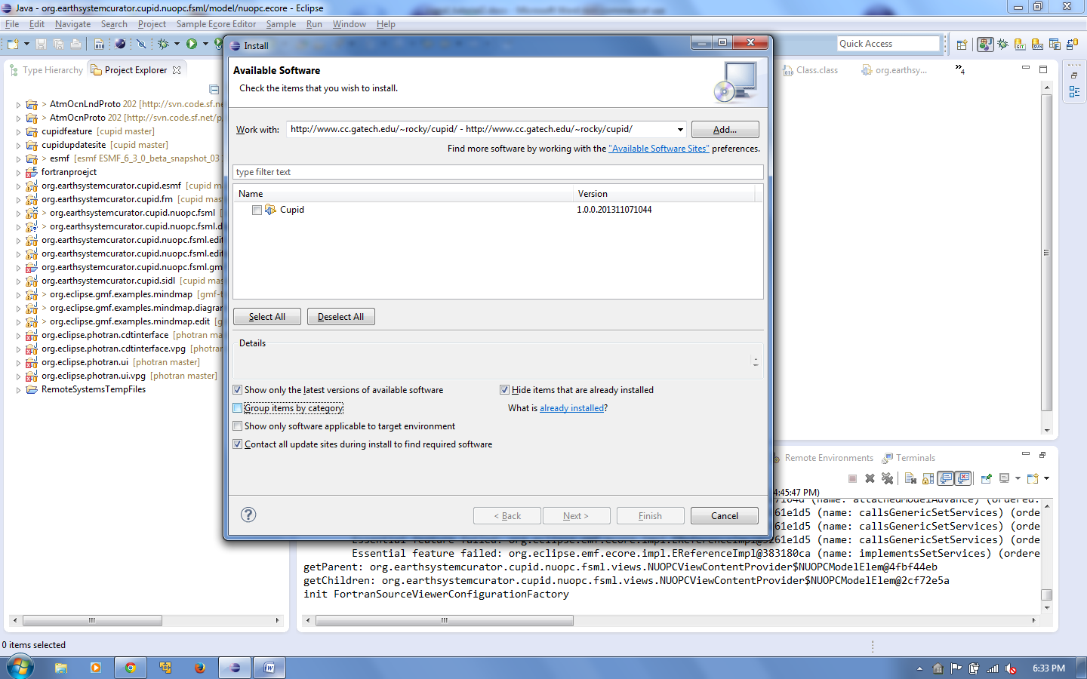

* 1. Select “Cupid” from the list and click Next.

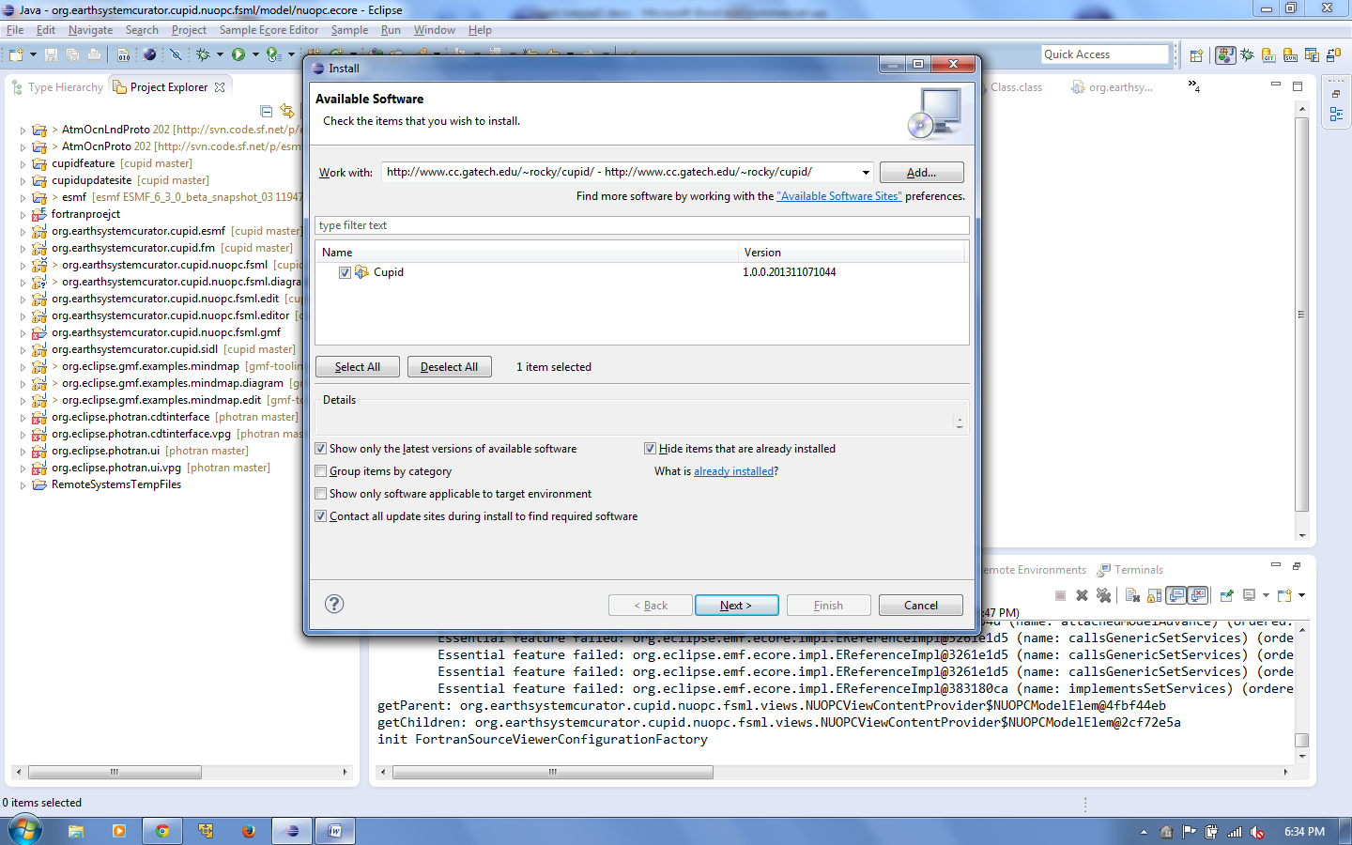

* 1. You will need to click Next a couple more times and accept the license agreements. Then click Finish. The Cupid plugin and its dependencies will be downloaded and installed.

During the process, you may receive a message that the software contains unsigned content. Click OK.

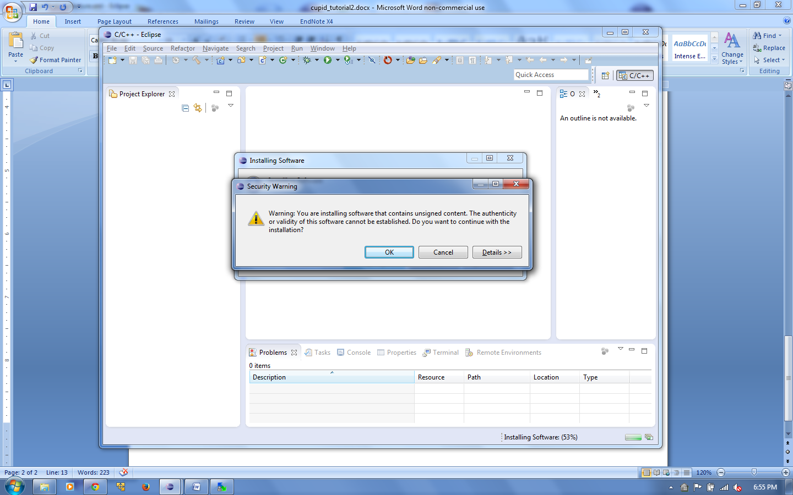

* 1. After installation, you will be prompted to restart Eclipse. Click Yes.

**Configure Cupid with Cloud Credentials**

Cupid creates cloud-based virtual machine instances to serve as the computational environment for the training scenarios. Currently, the only supported cloud provider is Amazon EC2. The first time you run Eclipse, you will need to set the Amazon EC2 credentials. You may use your own credentials or request access to the NESII cloud.

(Note: Cupid automatically launches Amazon machine instances when you create a new project. Alarms are set up to automatically kill instances after 50 minutes of idle CPU utilization. *However, it is your responsibility to ensure that any unused instances are terminated to avoid unnecessary cloud computing charges to your account*.)

1. In the Eclipse menu, select Window🡪Preferences. Then select Cupid Preferences in the list on the left.
2. Enter your Amazon Web Services (AWS) access key and secret key.

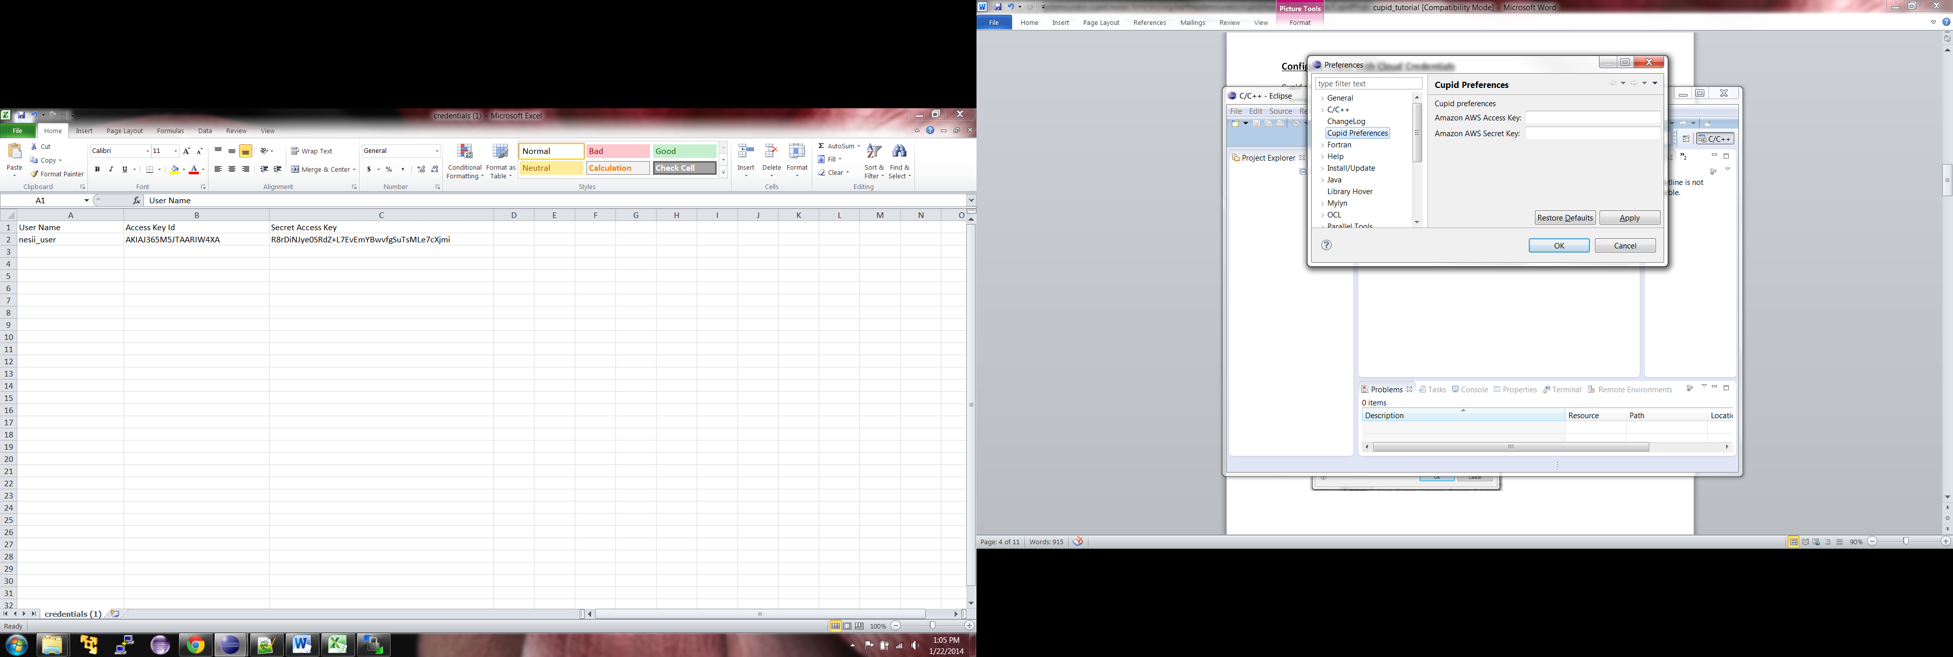

1. Click OK.

**Using Cheat Sheets**

An Eclipse Cheat Sheet is a step-by-step guide for performing some task in the IDE. Several Cheat Sheets have been provided that will help you get started using Cupid.

1. Select Help🡪Cheat Sheets from the Eclipse menu.
2. In the list at the top, choose the Cheat Sheet called “Create a New Cupid Training Project” in the Cupid folder.

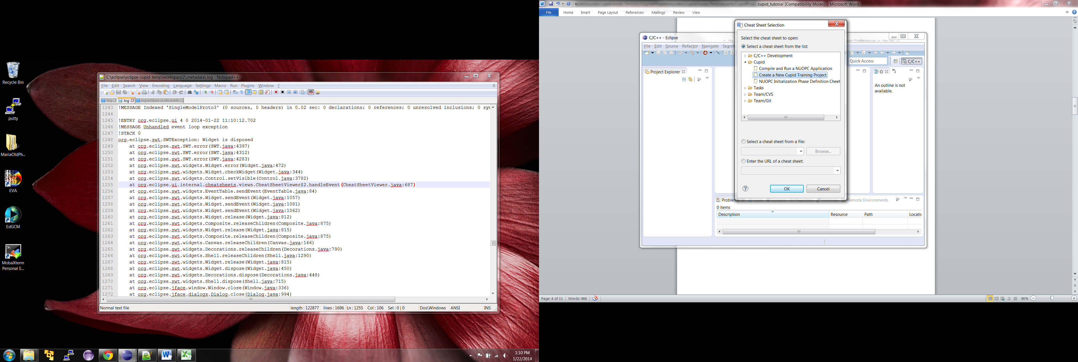

1. Click OK. You should see a new view in Eclipse showing the Cheat Sheet. At any time, to change Cheat Sheets, click on the small downward-facing triangle in the Cheat Sheet toolbar.

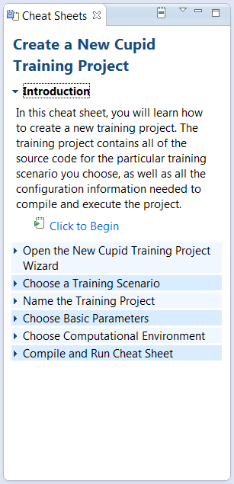

Click here to change Cheat Sheets

1. Follow the steps in the Cheat Sheet to create a new Cupid Training Project. The steps for creating a new project are also included in the next section of this tutorial.

**Create a New Cupid Training Project**

This section of the tutorial describes how to create a new Cupid Training Project. It is the same steps as outlined in the Cheat Sheet mentioned in the previous section.

1. Click File🡪New🡪Other… and choose Cupid Training Project in the Cupid folder. Click Next.

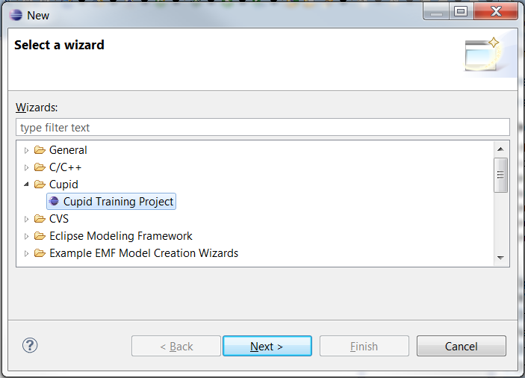

1. On the first page of the wizard, choose a training scenario. Several options are available, but currently on the first option is supported:

* NUOPC – Single Model with Driver
* NUOPC – Coupled Atmosphere-Ocean Driver ***(coming soon)***
* NUOPC – Coupled Atmosphere-Ocean with Mediator and Driver ***(coming soon)***
* ModelE – Basic Configuration (EM20 rundeck) ***(coming soon)***

Changing the training scenario in the list will update the screen to show the model architecture and coupling behavior of the selected scenario. Choose the scenario “NUOPC – Single Model with Driver” and click Next.

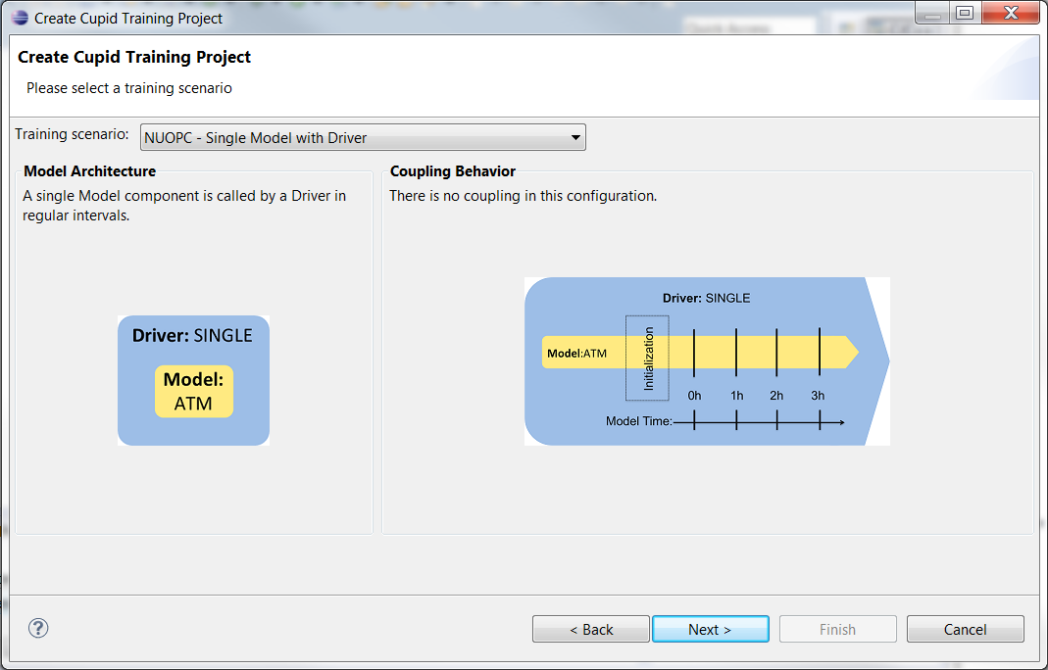

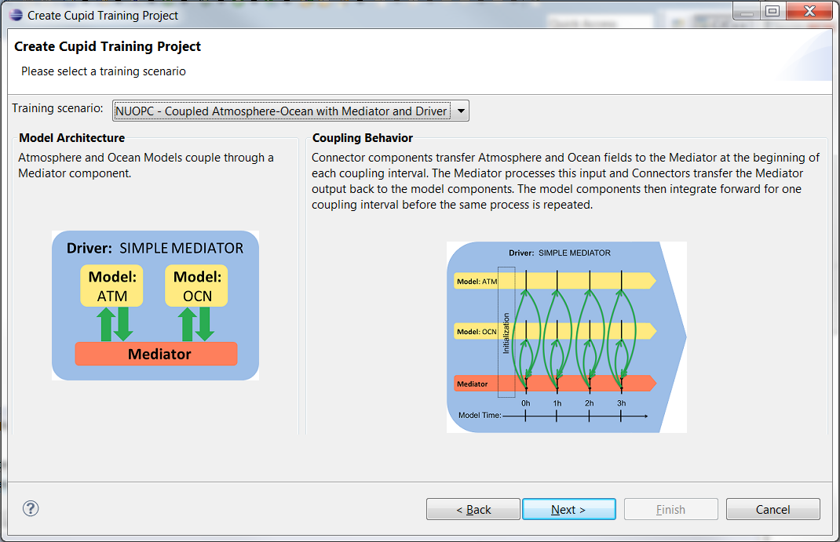

1. On this page, choose a name for your project or accept the default name. Note that project names must be unique, so you must choose a name that does not already exist in your workspace. Click Next.
2. On this page you can optionally set a few parameters supported by the training scenario. It is okay to leave all the default values. Click Next.

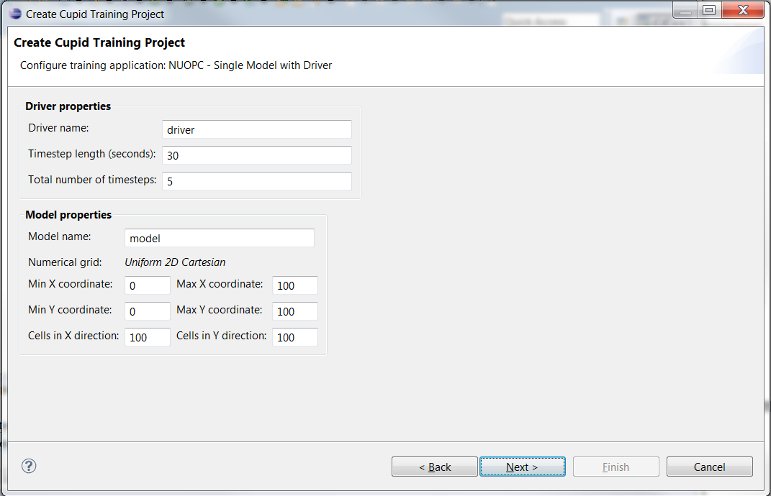

1. On this page you will choose a computational environment in which to compile and run the training scenario. The two options are:

* Create a cloud-based computational environment
* Use my local machine

The first option will create a preconfigured computational environment for you with all dependent software (model source code, Fortran compiler, MPI, NetCDF, ESMF, etc.). This is the recommended option unless you know you have a supported environment already set up locally. Choose the first option and leave the number of processes at 1. Click Finish.

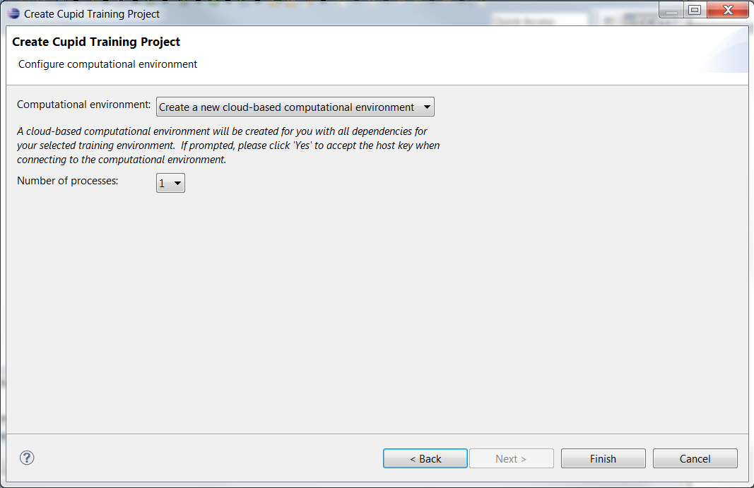

1. It will take up to several minutes for the new computational environment to start up. During this process you will be asked to accept the host SSH key. Click Yes.

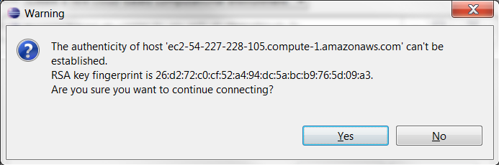

You may also be asked if you would like to switch to the Cupid Perspective. An Eclipse perspective is a particular screen layout customized for specific tasks. The Cupid Perspective hides a number of Eclipse tools and commands that are not required for the training. Click Yes to switch to the Cupid Perspective.

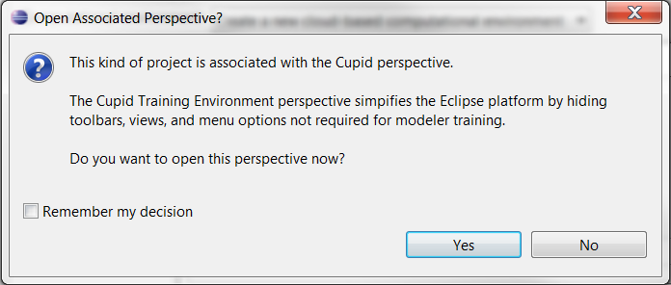

1. You should now see your project in the Project Explorer. The Cupid Perspective also exposes several other views including a Fortran source code editor, a Make Target view on the right for compiling your code and a Console at the bottom for viewing output from the compiler.

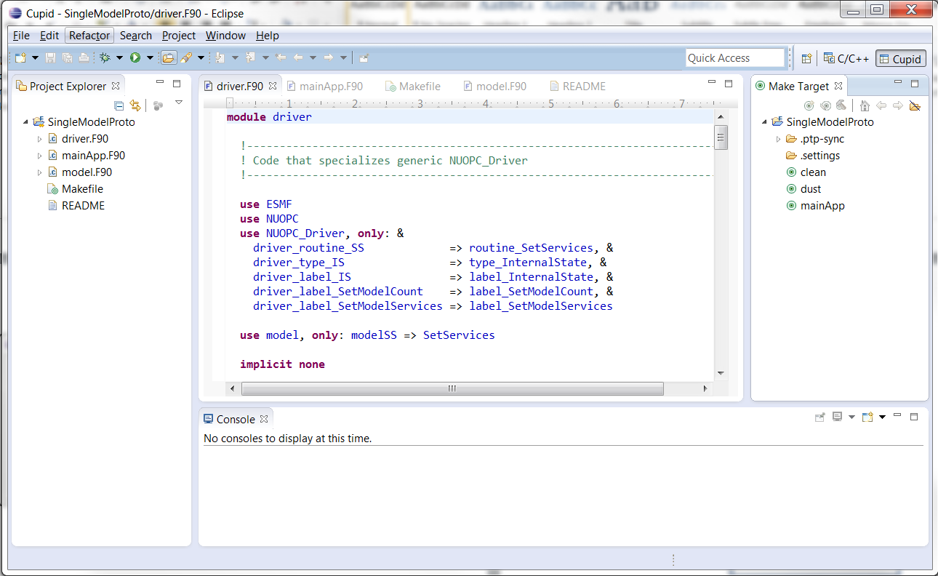

**Source code editor**

**Make targets**

**Project Explorer**

**Console for viewing compiler output**

**Compile and Run the NUOPC Single Model with Driver training scenario**

In this section of the tutorial, you will learn how to compile and execute the source code provided in the NUOPC Single Model with Driver training scenario. A Cheat Sheet is available for this task. (Click Help🡪Cheat Sheets and choose “Compile and Run a NUOPC Application” in the Cupid folder.)

1. Ensure that the Make Target view is showing (see below). If not, choose Window🡪Show View🡪Other… and select “Make Target” under the Make folder.

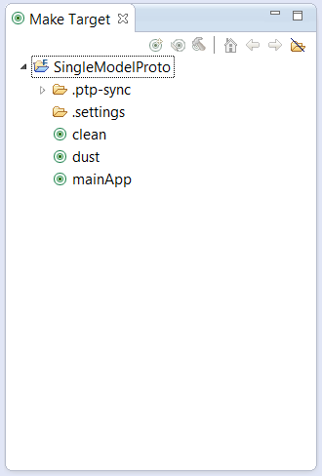

1. If you used the New Cupid Training Project wizard to set up the training scenario, then the correct make targets have already been set up. To compile the NUOPC application, double click the “mainApp” target. You should be able to see the compiler output in the Console.

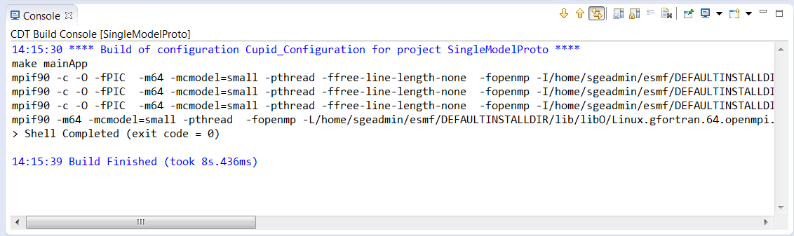

1. To run the compiled code, you must set up a run configuration. *(Note: This step will be automated in a future release of Cupid.)* Click the down arrow next to the Run As... button in the toolbar (green circle with a while arrow) and choose Run Configurations… from the popup menu.

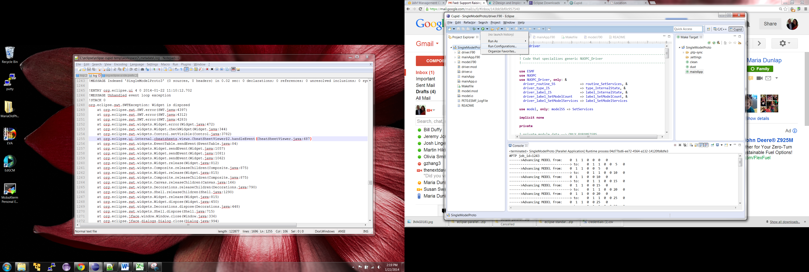

1. In the Run Configurations dialog, right click on Parallel Application and choose “New.” Configure the run configuration as follows:

* Resources tab
  + Target System Configuration: **Open MPI-Generic-Interactive**
  + Connection type: **Remote**
  + Connection: **Cupid Environment (Amazon EC2 <ip address>)**
* Application tab
  + Project: should default to your project name
  + Application program: Click Browse and select “mainApp”. The final path should be **/home/sgeadmin/SingleModelProto/mainApp**
* Click Apply then Run

1. Once the Run Configuration has been created, you do not need to set it up again unless you need to change some configuration settings. After running it the first time, the run configuration should be available in the Run Configurations dropdown list on the toolbar.

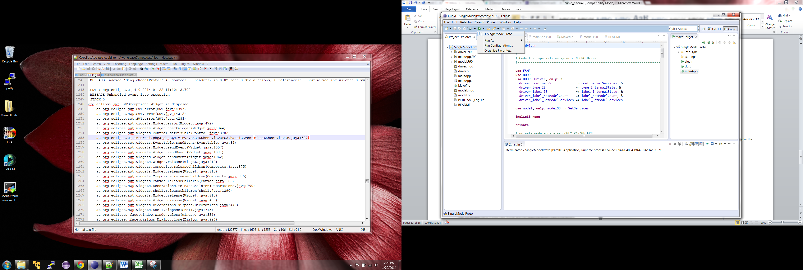

1. Output from the run will be shown in the Console view.

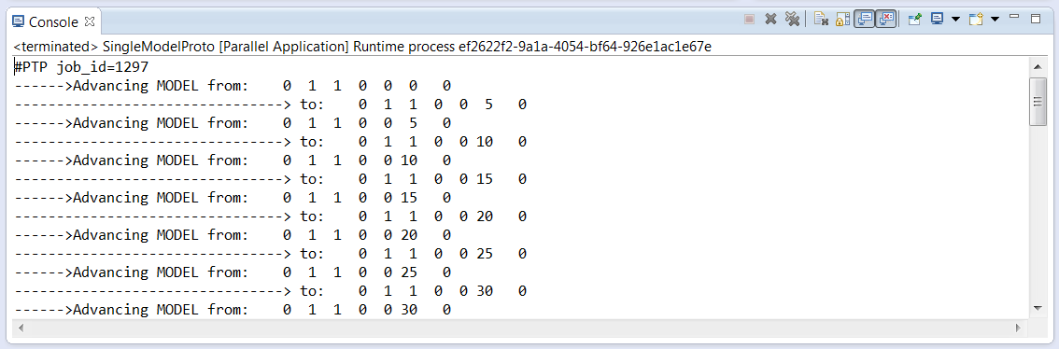

**Show the NUOPC tree viewer.**

Click the Window menu🡪Show View🡪Other and then select the NUOPC View in the NUOPC Category.

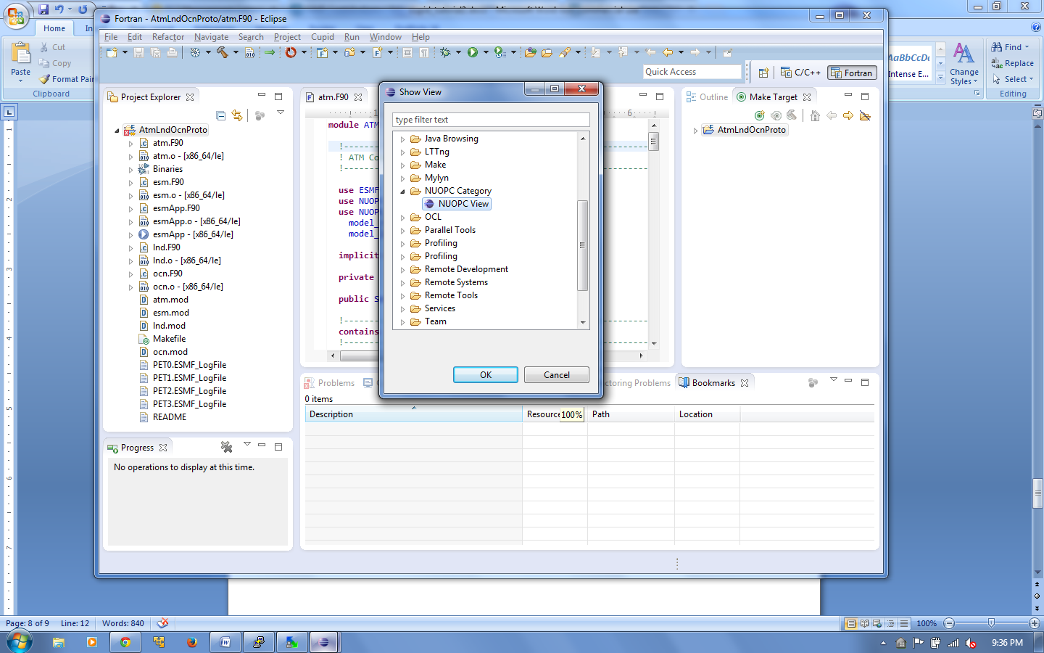

The NUOPC view will appear and will initially be empty. The view can be moved by dragging the “NUOPC View” tab to another part of the screen.

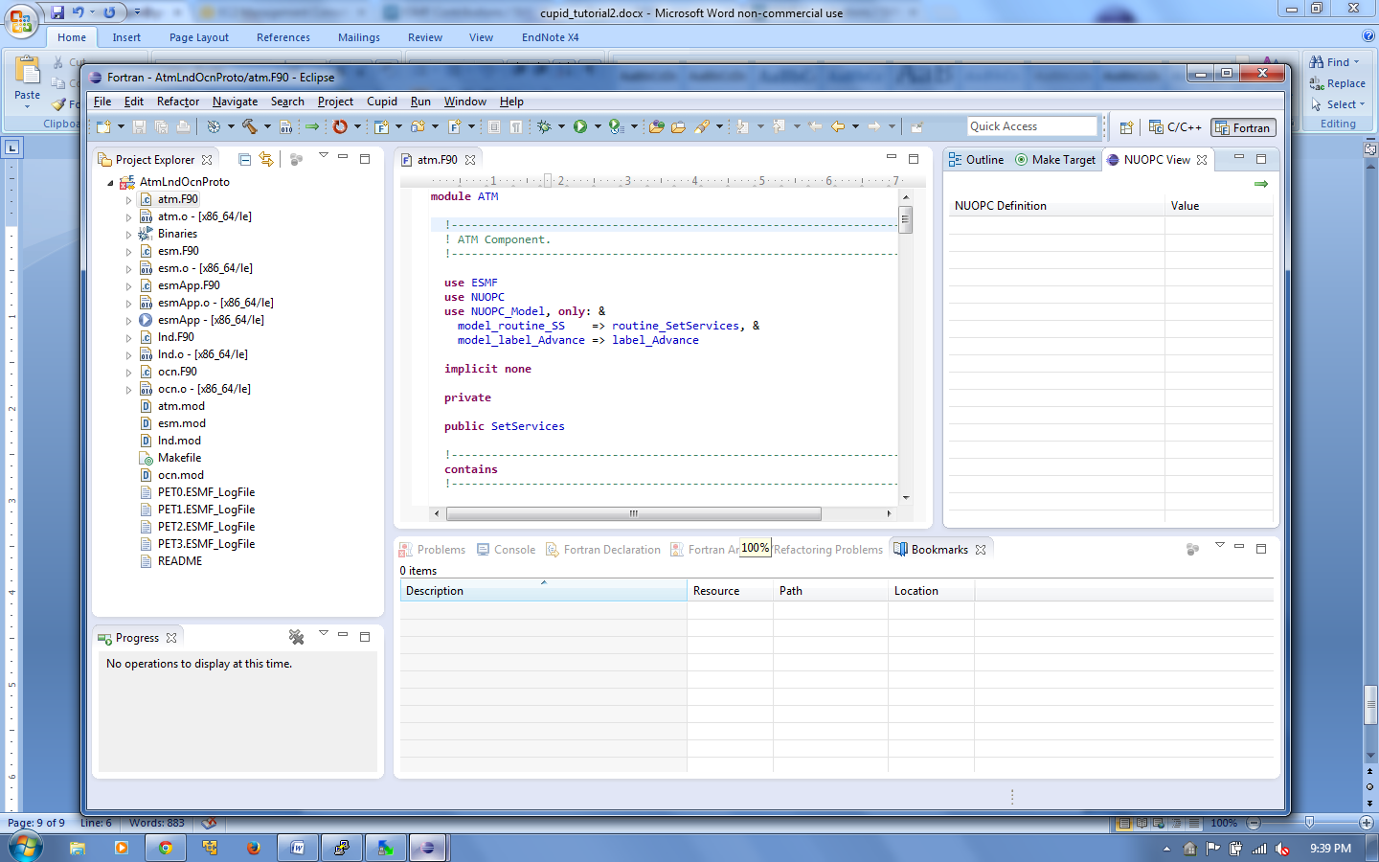

1. **Reverse engineer the AtmOcnLndProto project.**
   1. Open any of the .F90 files in the AtmOcnLndProto project by double clicking on the file name. The selected file tells Cupid which project to reverse engineer. (It is possible to have multiple NUOPC projects in the same workspace.)
   2. Click the green arrow in the top-right corner of the NUOPC View or select Cupid🡪Reverse Engineer from the menu. The NUOPC View will update with a tree structure representing the reverse engineered model.

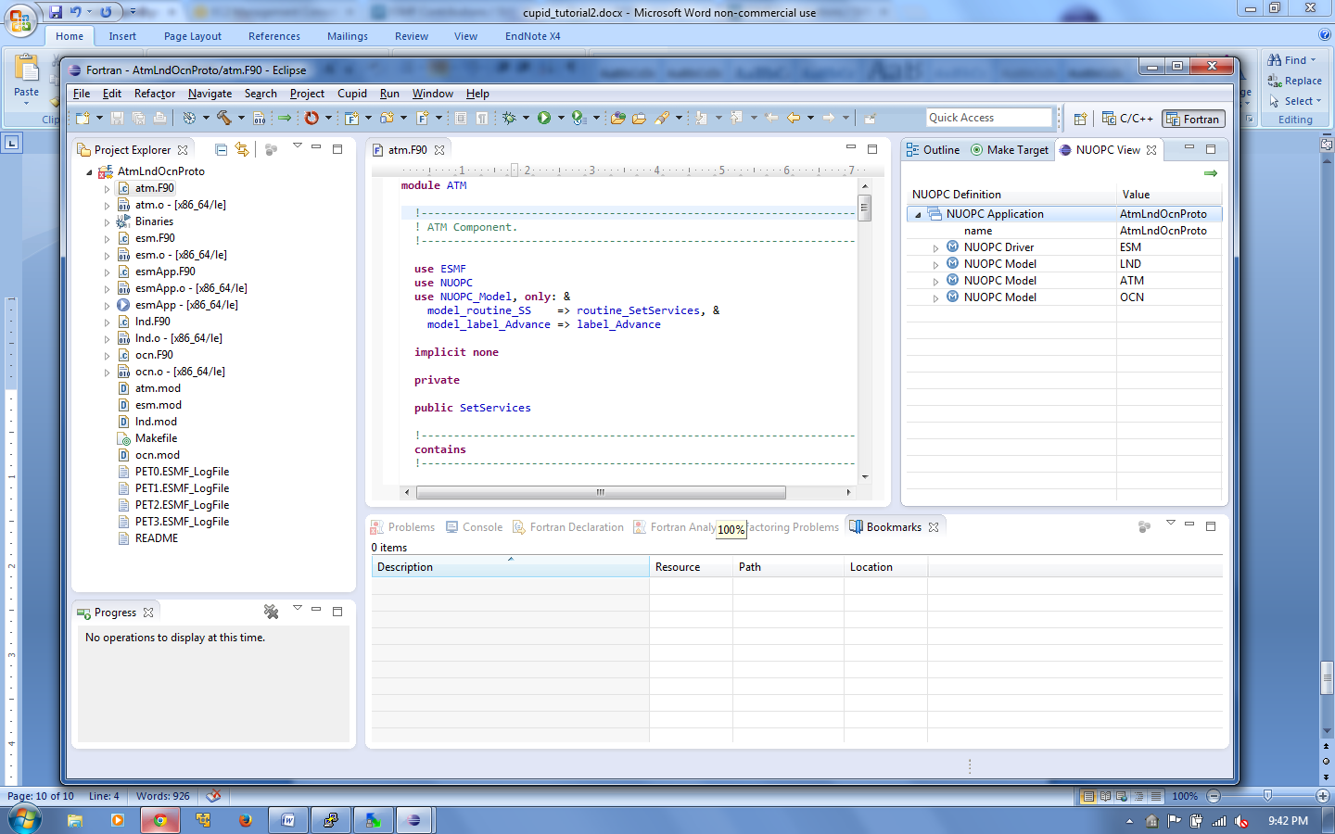

* 1. Expand the tree to see what NUOPC code patterns were discovered by Cupid.

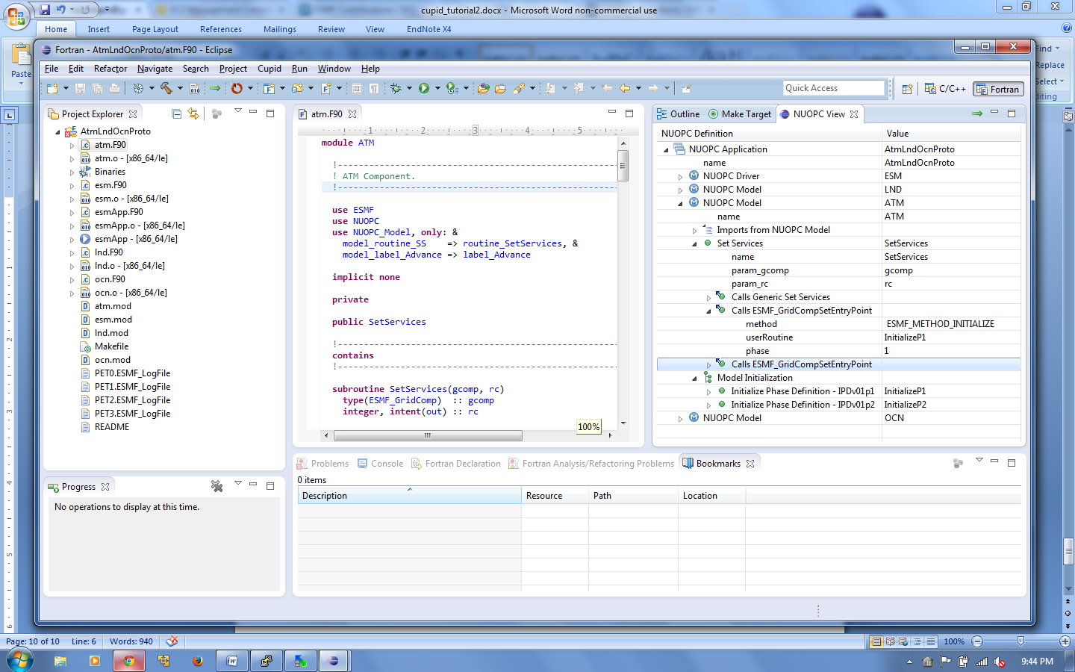

1. **Show a NUOPC compliance issue using Cupid.**

Cupid can automatically indicate NUOPC compliance problems that would hinder interoperability of a codebase with other NUOPC components. The AtmOcnLndProto code is already NUOPC compliant, but we will introduce a problem in order to show how Cupid reports validation errors.

* 1. Open the file **lnd.F90** and comment out the subroutine InitializeP1. We will assume that the developer forgot to implement this subroutine, or knows about it but simply hasn’t written it yet.

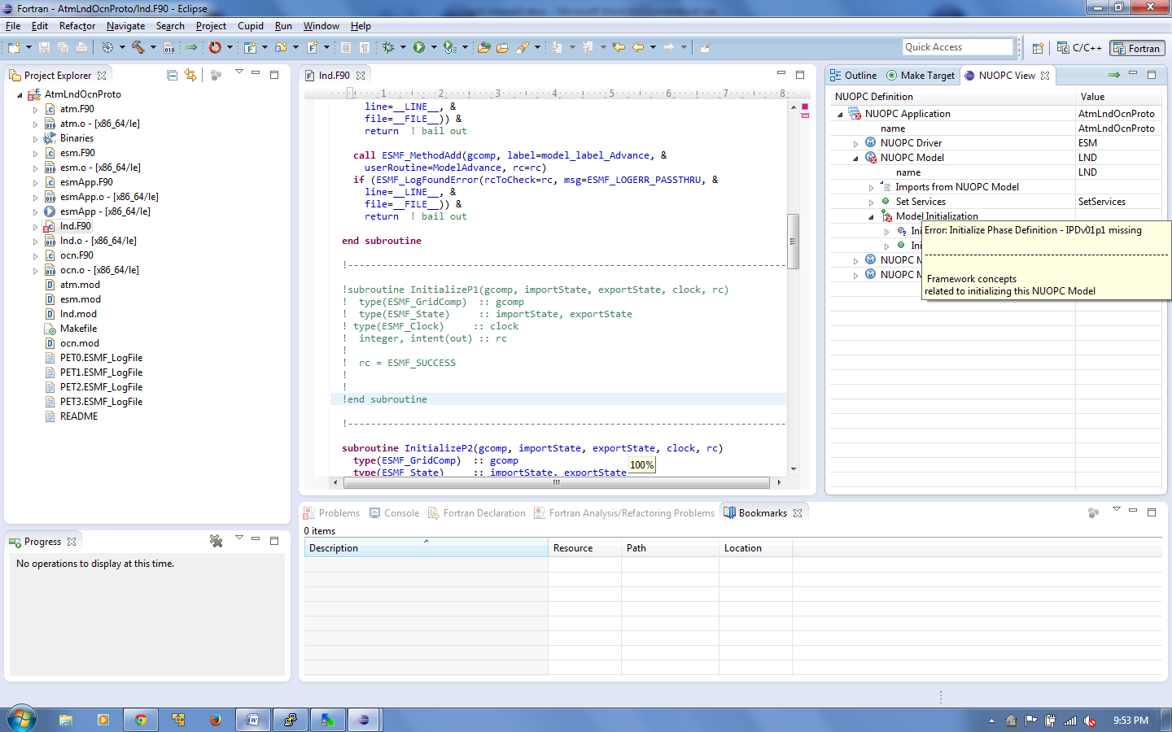

* 1. Save the modified **lnd.F90** file. Then, click the reverse engineer button again to re-analyze the code and update the NUOPC View. The view should now indicate an error with a small red X over the invalid node(s) in the tree. Hovering over the invalid node shows a description of the validation error.



1. **Use Cupid’s Quick Fix feature to generate missing code.**
   1. Scroll to the top of the **lnd.F90** file. The module name LND has been underlined in red indicating that the module has failed validation and is not NUOPC compliant.
   2. Hover over the module name to show available quick fixes.

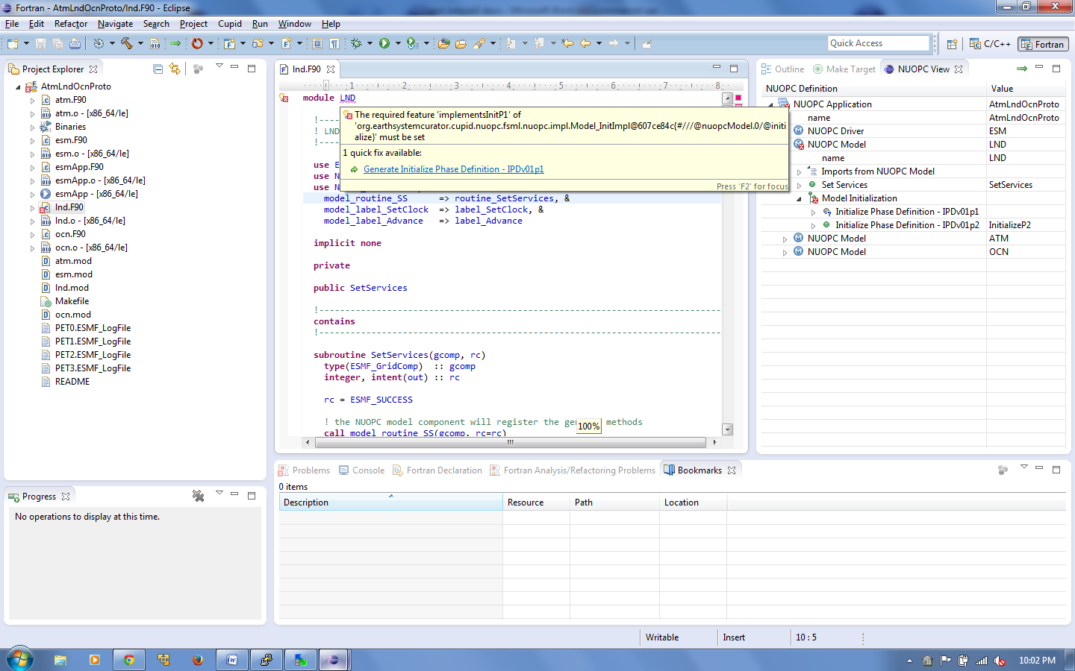

* 1. Click on the one quick fix available: “Generate Initialize Phase Definition - IPDv01p1”
  2. A new subroutine skeleton named InitP1 is generated automatically and inserted at the end of the module. The generated code is bookmarked and highlighted in yellow on the right vertical ruler to make it easy to distinquish the generated code from the existing code.

